
Test Generation and
Compression
• The submitted manuscript must be 2-4 pages, double-columned, IEEE-style compatible, in PDF format only.
→ In Stage Two (paper submission), authors must electronically submit the self-contained paper with figures
and tables via the same submission page before Nov. 15, 2021.
→ In Stage One (abstract submission), a title, an 80- to 100-word abstract, and a list of all co-authors must be
submitted via the conference submission page before Nov. 01, 2021. No abstract submissions after the
deadline.
➲ GENERAL INSTRUCTIONS
• Prospective authors are asked to submit their work in two stages for VLSI-DAT 2022.
Test Standards
Power/Thermal
Estimation and
Optimization
Modeling and
Simulation
Enhancement
Verification
Physical Design and Yield and Reliability
Circuits and Systems
SOC and System
Level Test
Ultra Low-Power
Diagnosis
Co-Design
Logic and
Behavioral
Synthesis
Wired and IO Design
Hardware/Software Silicon Debug and
2022 International Symposium on
VLSI Design, Automation and Test (2022 VLSI-DAT)
Analog EDA
Manufacturability
and Software
ASICs
and Power
Design-for-Testability Hardware-efficient
Design for
Digital Circuits and Embedded System
Energy-Harvesting
Architecture for AI
Test
Architectures
Baseband Designs
Interposer-Based IC Hardware
Level Design
Communication
Biomedical Circuits
Specialized
3D IC and
CPU, DSP and
Multicore
APPLICATIONS
TEST
EDA
SOC
ANALOG DESIGN DIGITAL DESIGN
AI
The 2022 International Symposium on VLSI Design, Automation and Test will be held on April 18-21, 2022,
at the Ambassador Hotel, Hsinchu, Taiwan. Original and unpublished papers on all aspects of VLSI Design,
Automation and Test are solicited, including but not limited to:
Second Call for Papers
AI Methods
Mixed-Signal Test
Designs
Systems
Signal Circuits
Security Circuits for
IoT and AI
AI for Systems
Systems for AI
RF, Analog and Mixed Memory Circuits and System-in-Package Electronic System RF, Analog and
Biochips
Neuromorphic Circuits
On-Chip Monitoring AI for EDA
EDA for Microfluidic
SOC and NOC
Architectures
Memristive and
Low Voltage & Low
Power Circuits
Design
Processing Designs
and Trust
Circuits
Design Verification Memory Test
Compiler for AI
Accelerators
Multimedia
Sensor and Interface Hardware Security
Management Circuits
and BIST

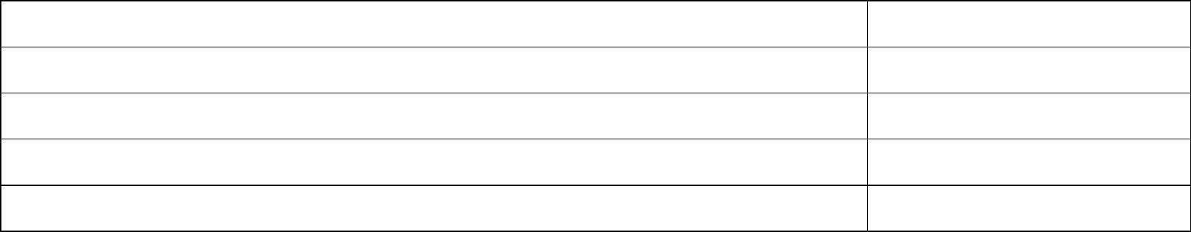
Before submitting your abstract/paper, please review the information on IEEE Intellectual Property Rights at
https://www.ieee.org/web/publications/rights/index.html
VLSI-DAT adopts the double-blind review process; please DO NOT reveal your name(s) or affiliation(s)
anywhere in the submitted manuscript for the first paper submission.
•
•
Any submissions not adhering to the rules will be rejected immediately without review.
Second Call for Papers
•
•
Note: all are based on Taiwan time (GMT+8).
E-mail: shigeki.tomishima@intel.com
E-mail:cthuang@cs.nthu.edu.tw
E-mail: racy.cheng@itri.org.tw
Intel, USA
Industrial Technology Research Institute,
Taiwan
Dr. Shigeki Tomishima
Prof. Chih-Tsun Huang
National Tsing Hua University,
Taiwan
Dr. Racy Cheng
2022 Technical Program Co-Chairs
Deadline for Final Paper (IEEE compatible version) Submission
Deadline for Author Registration Deadline
Nov. 01, 2021
Nov. 15, 2021
Dec. 30, 2021
Jan. 31, 2022
Feb. 28, 2022
Deadline for Title/Abstract Submission (Extension)
Deadline for Camera-Ready Paper Submission (Extension)
Notification of Acceptance
➲ IMPORTANT DATES
Three best papers will be selected this year through a rigorous evaluation process conducted by the program
committee and session chairs.
➲ BEST PAPER AWARD
•
➲ STUDENT SUBSIDY
Financial supports are available for full-time student presenters living outside of Taiwan.
Please refer to the detailed information on the conference website for authors:
https://expo.itri.org.tw/2022vlsidat
No-show papers will not be included in the symposium proceedings and will not be submitted to the IEEE
Xplore database.
•
•
For an accepted paper to be published in the proceedings, one of its co-author(s) MUST register and attend
the symposium to present the paper. Note that each accepted paper shall be accompanied by a distinct
registration; that is, two registrations are required for presenting two papers even if the presenter is the same.
Presentation of accepted papers at the symposium must be in English and limited to 18 minutes, with an
additional 2 minutes for Q&A. The final manuscripts of all accepted papers will be published as submitted in
the proceedings.
•
•
The notices of acceptance will be sent out to authors on December 30, 2021.
Any changes on the title and author list or withdrawal after acceptance must be approved by Technical
Program Co-Chairs.

